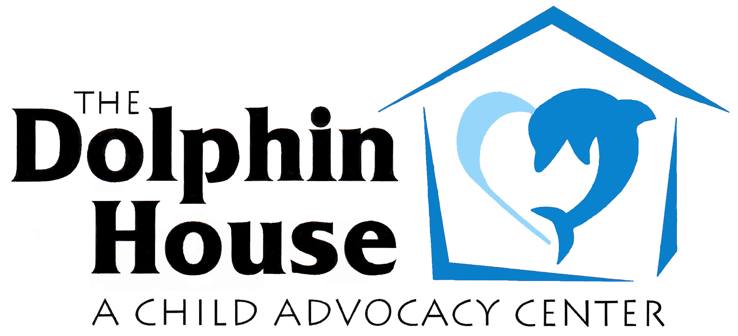

The Dolphin House Child Advocacy Center is a nationally accredited, non-profit child advocacy center located in Montrose, Colorado. The mission of the Center is to serve and support victims of child abuse in the 7th Judicial District and provide them with hope, help and healing. The Center assists in the coordination and facilitation of the multiple professional agencies and individuals that are involved in the complexities of child sexual abuse cases, physical abuse cases, and witnesses to violence. The Center provides a neutral, child and family friendly environment for forensic interviews, family support and advocacy, mental health services, and medical services.

POSITION TITLE: Family Advocate/Victim Services Coordinator

The Family Advocate/Victim Services Coordinator is a full-time position based in the center’s Montrose facility. This position reports directly to the Executive Director. This position provides initial crisis support, coordinates initial and ongoing victim services for child abuse victims, and provides oversight for the Victim Services Assistant for case management, interview and exam scheduling and database input.

REQUIRED SKILLS AND EDUCATION:
- A demonstrated knowledge of child and family development;
- Case intake and database management experience;
- Highly motivated, flexible, organized, and is a team player;
- Working knowledge of office systems and equipment including Microsoft Office;
- Ability to work efficiently with minimal supervision;
- Ability to manage and prioritize multiple tasks;
- Excellent verbal and written skills.

Preferred Skills and Education:
- Bachelor’s degree in social work or related field;
- Experience working with families in crisis;
- Knowledge of forensic interview and child advocacy center practices;
- Spanish-speaking.

SPECIFIC RESPONSIBILITIES:

- Makes initial contact with families prior to forensic interviews and medical exams;
- Completes intake paperwork for forensic interviews and medical exams;
- Provides initial crisis support for child abuse victims upon arrival for forensic interviews and/or medical evaluations;
- Provides information to victims regarding Victim Rights and Crime Victims Compensation, and provides assistance in completing forms as needed;
- Educates family about the dynamics of abuse and trauma;
- Provides ongoing support to the child and family as needed throughout the investigation, intervention and prosecution phases;
- Works with the Mental Health Clinician who assesses the child(ren) and caregiver(s) to determine if treatment is necessary;
- Makes mental health referrals to trauma-trained clinicians;
- Communicates regularly with parents/guardians during the entire process to ascertain whether child abuse victims are receiving help and support needed;
- Works with other Victim Service Agencies to make sure the victim is receiving all services needed;
- Follows up on all Multidisciplinary Team case reviews and enters case progress into the database;
- In absence of Forensic Interviewer Coordinator, facilitates observation equipment, finalizes DVDs and distributes interview “evidence” to appropriate agencies.

Community Education and Involvement:
- Represents the Dolphin House on the Sexual Assault Response Team

Other duties as assigned.

